Steps for order creation

**Sample Receiver**

Initial Stage Module, whenever new samples are received by the sampler than first entry should be done on samples section. This is the first step on order booking process, after sampling other steps will be processing.

**Sales Samples**

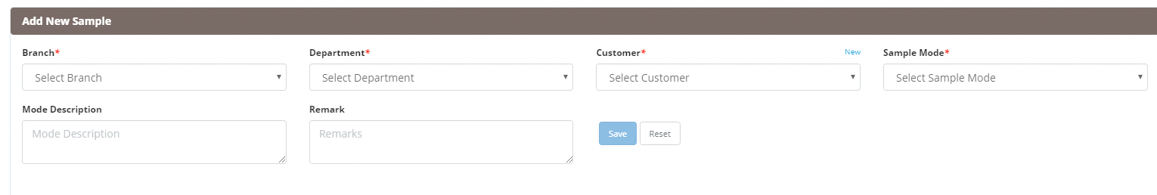

**Branch:**

Sampler need to select the branch if sample received in Chennai branch than need to select Chennai from the dropdown.

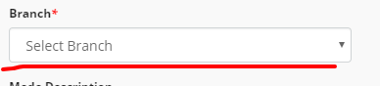

**Department:**

Sampler need to select the department of the sample from the dropdown list i.e. Food, Pharma, Water etc.

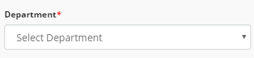

**Customer:**

Sampler need to select the customer from the dropdown list, if the customer is the existing customer than it will display on the dropdown list.

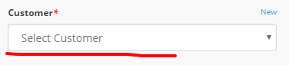

if the customer not registered with ITC than sample need to create the customer by clicking on **new button**. Once sampler registers the customer than automatically a request mail sends to the administrator regarding this and admin register this customer on the customer master

**custom.png**

**Sample Mode**

Sampler need to select the mode of the sample either received directly or through Courier or through marketing person.

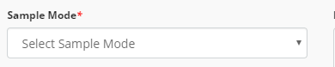

**These all above are the mandatory parameters.**

Also have the option for the mode description and the remark if any.

  
Sampler can view the entry on the index page.

Sample no F-18XXXXXXXX

So the first character showing the department name like if received sample from the food department than sample number start from letter F, if from pharma then P-18XXXXXXX.

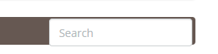

Also provided the search functionality where sampler can search the sample according to Sample number, Section name, Date, Customer name and place.